# 

# REPORT ON THE CURRICULUM, PEDAGOGY AND TECHNOLOGY

A workshop on "**Curriculum, Pedagogy, and Technology"** was held on 25 April 2025 at Summer Fields School. This workshop aimed at enhancing the understanding of contemporary educational practices among educators.

The workshop began at 9:00 a.m. and went on till 11:00 a.m. The session began with the welcome note and introduction of the distinguished resource person Mrs. Shweta Kapoor, a master trainer and an educational consultant, who brought valuable insights into how the integration of curriculum planning, modern pedagogy, and technological tools can significantly improve teaching and learning outcomes.

Mrs. Shweta Kapoor emphasized the importance of designing a learner-centric curriculum that aligns with 21st-century skills. She introduced innovative pedagogical strategies such as project-based learning, flipped classrooms, and blended learning models. A key highlight of the session was the demonstration of various educational technologies and platforms that can aid in interactive and personalized learning.

During the session, a meaningful poem shared by one of the respected teachers beautifully captured the essence of the workshop:

पाठ्यक्रम की संभावनाएं,

तब सज जाती हैं,

अध्यापन तकनीकों के,

जब रंग रंग जाती हैं,

उचित शिक्षा जैसे है ज़रूरी,

वैसे ही शिक्षा शास्त्र,

ऊंचे ऊंचे शिखर जा पहुंचे,

रहे न कठिनाई मात्र,

छात्रों के भविष्य की रंगत,

निखर ही जाती है।

This poem aptly reflected the idea that curriculum possibilities truly blossom when combined with vibrant teaching techniques.

Another significant point brought up by the speaker, Mrs. Kapoor, was:

**"A learner's journey is the gap between what we learn and how we are assessed."**

This powerful statement highlighted the need to align teaching methods and assessment patterns with actual learning processes to bridge the gap and truly support student development.

The teachers were engaged in hands-on activities and group discussions, exploring how to effectively incorporate these strategies into their own teaching practices. The workshop concluded with a Q&A session, where the resource person addressed queries and shared practical tips for classroom implementation.

Overall, the workshop was highly informative and inspiring. It equipped educators with new perspectives and tools to enhance their teaching methods and better engage with students in the digital age.

Assessment based on the understanding of the said topic was done for teachers and feedback forms were also filled.

The workshop was an enriching and a learning experience for all the attendees.

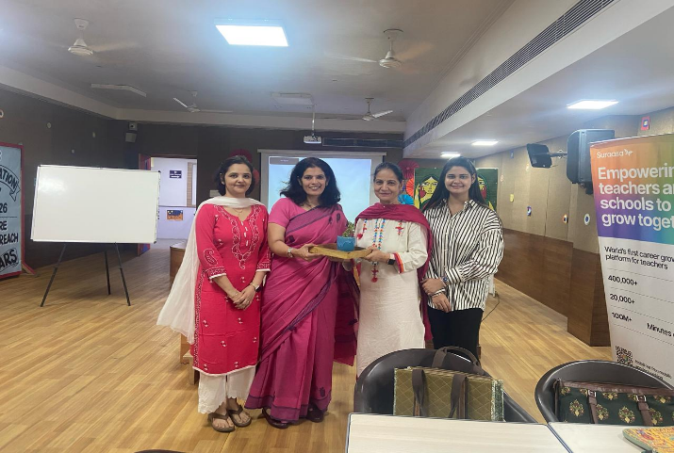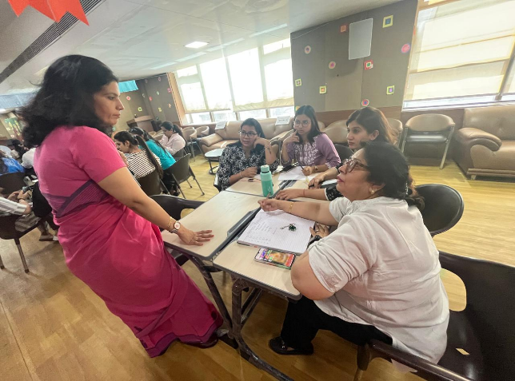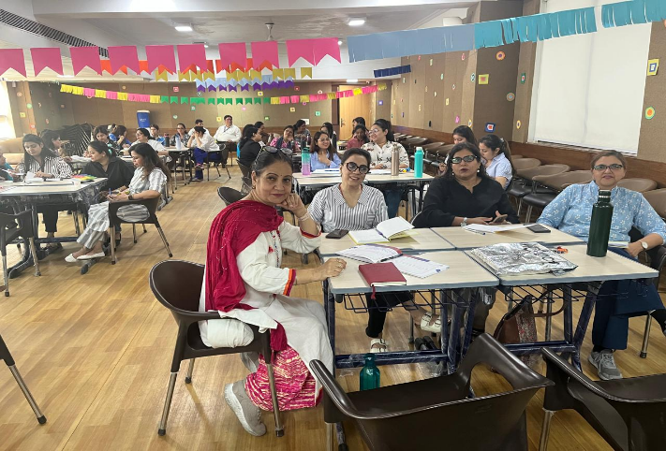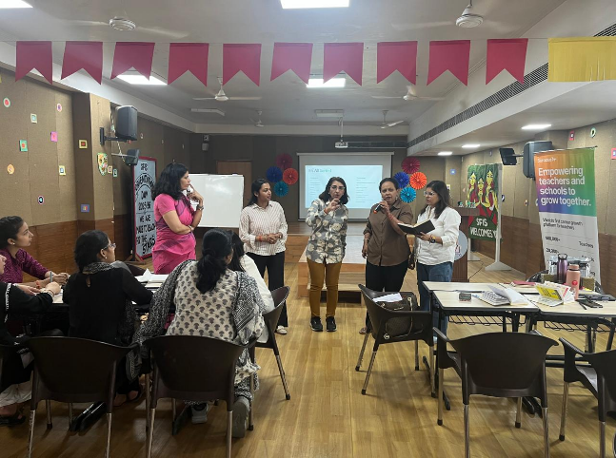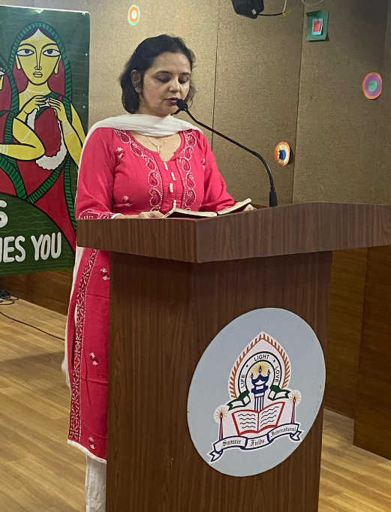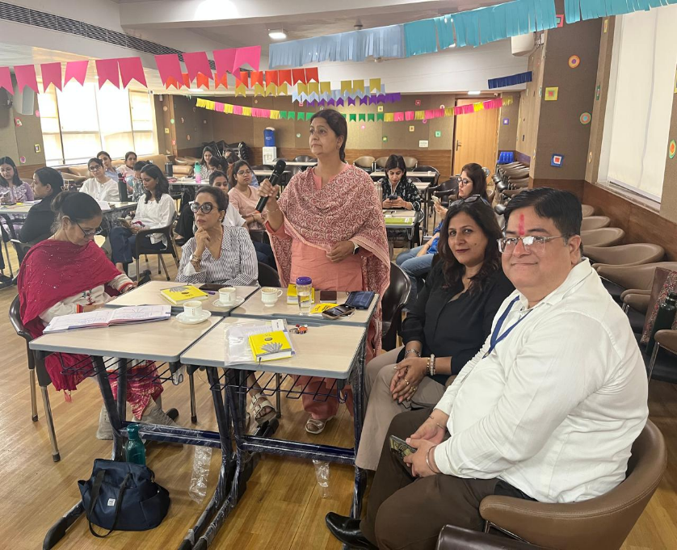



_______________

Shalini Agarwal

PRINCIPAL